T
JJAD Development Group

Leave blank

Table of Contents
Mission Statement and Goals 1
Requisition Correspondence 2
Request for Information 2
Request for Information Response 3
Request for Proposal 4
Request for Proposal 6
Request For Proposal Response 15
Timeline 16
Budget 17
Floor Plan Information 21
Legend 21
Diagram 22
Satellite Locations 26
Hardware 27
Software 38
Recommendations Only 44
Security Policies 45
Password Policy Recommendation 46
Backup and Disaster Recovery Policy 47
Appendix A: Website 48
Appendix B: Packet Tracer 49
Works Cited 50

Leave Blank

Team
Julian Vazquez – Project Manager
Dimitry Sitnikov – Back-End Developer
Jarrod Brown – Front-End Developer

Mission Statement and Goals

Mission Statement:
JJAD Development Group’s mission is to provide secure, scalable, and cost-effective IT solutions that strengthen our clients’ operations through reliable service, professional execution, and lasting partnerships.​

Goals:
- Deliver Quality IT Solutions
- Build Strong Client Relationships
- Stay Current with Technology

Requisition Correspondence

Request for Information

January 27, 2026

Julian Vazquez
JJAD Development Group
2050 Hwy 501 E
Bldg. 1000 Suite 322
Conway, SC 29526
RE: Request for Information
To Whom It May Concern:

This letter is a request for information on a new project TCTB Technology Solutions is directing. The project is a newly constructed state-of-the art training facility for restaurants. The facility is currently under contract to begin construction and will be ready for the technology phase to begin on May 3, 2026.

Qualifications for the right vendor will include, but are not limited to, the ability to recommend the proper equipment, software, installation of the network, database implementation, server, security of the system, and training as needed. This project will be bid on by several IT companies, and the budget will be determined by your company’s research and recommendations.

If you are selected, your company will need to provide a recommendation on the placement of the equipment and proper placement of our server room. Upon being chosen, a floor plan will be provided. Specifications will be given upon receiving your response to this letter.

If your company is interested in providing the services mentioned above and is available to give weekly updates, as well as beginning the implementation phase by May 3, 2026, please submit a letter of interest by February 1, 2026. Please include your company’s expertise, skills and other information you find pertinent to being chosen as the vendor for this endeavor.

If you are chosen to bid on the project, you will receive a Request for Proposal with the full requirements set forth. Thank you for your time. We look forward to hearing from you.

Sincerely,

LouAnn Timmons
Lou Ann Timmons, CEO
TCTB Technology Solutions

2050 Hwy 501 E; Suite 304C; Conway, SC 29526
(843) 349-5367
Louann.timmons@hgtc.edu

Request for Information Response

January 31, 2026
Mrs. Lou Ann Timmons, CEO
TCTB Technology Solutions
2050 Hwy 501 E
Bldg. 1000 Suite 304C
Conway, SC 29526

RE: Response to Request for Information

Dear Mrs. Timmons,
On behalf of JJAD Development Group, I would like to formally express our interest in providing information and potential services for the technological implementation of your new state-of-the-art restaurant training facility project.
JJAD Development Group is an emerging IT solutions company specializing in infrastructure design, network deployment, server and database implementation, system security, and user training. Our team has experience supporting projects that require thoughtful planning, scalable architecture, and secure, reliable systems.
We are confident in our ability to:
- Recommend appropriate hardware, software, and networking solutions
- Design and install structured cabling and network infrastructure
- Implement database and server infrastructure solutions
- Provide security planning and system hardening
If selected, JJAD Development Group is prepared to provide detailed recommendations regarding equipment placement, server room design, and overall infrastructure layout once facility specifications and floor plans are made available.
We are available to begin the implementation phase by May 3, 2026, and would welcome the opportunity to participate in the bidding process should we be selected to receive the Request for Proposal.
Sincerely,
Julian Vazquez
Julian Vazquez, Project Manager
JJAD Development Group

2050 Hwy 501 E; Bldg. 1000 Suite 322; Conway, SC 29526
Jvazque5@hgtc.edu

Request for Proposal
February 11, 2026
Julian Vazquez
JJAD Development Group
2050 Hwy 501 E
Bldg. 1000C Room 322
Conway, SC 29526

Re: Request for Proposal
Dear Mr. Vazquez,

It is our great pleasure to welcome you and your team of consultants to prepare a business plan and proposal to bid on the new state-of-the-art training facility for the TCTB Technology Solutions.

After our initial interview with your team, my colleagues and I discussed the many needs for our one-of-a-kind facility. Attached you will find a Request for Proposal in which we have compiled a list of items to assist you during the design phase and to ensure the needs for our instructors, students, and managers are met. You will also find attached a list of hardware, software, and our mission statement/vision for our company.

If you accept this endeavor, please send a letter of acceptance no later than February 22, 2026. Also, if you should have any questions regarding the attachments, please feel free to contact us either via e-mail at louann.timmons@hgtc.edu or via phone at (843) 349-5367.
We look forward to reviewing your business plan and working with you throughout the course of the project. Thank you for your time.

Sincerely,
LouAnn Timmons
Lou Ann Timmons, CEO
TCTB Technology Solutions

Attachments (3)

2050 Hwy 501 E; Suite 304C; Conway, SC 29526
(843) 349-5367
Louann.timmons@hgtc.edu


TCTB Technology Solutions Mission Statement & Vision
Mission Statement
TCTB Technology Solutions delivers high-quality, state-of-the-art training environments through meticulous attention to detail and a commitment to learner success.
Vision
We envision a future where TCTB Technology Solutions leads the evolution of workforce training, setting the standard for innovative, state-of-the-art education across Horry and Georgetown Counties.

TCTB Technology Solutions Organizational Chart

Request for Proposal

From: TCTB Technology Solutions
Request for Proposal (RFP): Analyze, Design, and Develop New System
Reference Number: C02 – 2026 – 06
Issue Date: February 11, 2026

1) Disclaimer:
This is only a request for information for services and does not express or imply any representation or indicate a commitment to any vendor or consultant’s services or proposal.
2) Background:
The TCTB Technology Solutions Department of Information Technology is seeking information and services for the following:
- Network
- Equipment
- Software
- Satellite Offices (2 different cities and states)
This request is being sought for a training institute in the Horry and Georgetown County Areas and recommendations for two satellite offices.
Information should include but is not limited to: timeline to complete the project; cost of equipment, software, and setup; cost of services; and recommended equipment and software, along with a website, database and security.
3) Purpose:
This Request for Proposal is a gathering of information process in which the “TCTB Technology Solutions” franchise seeks to collect information and opinions from Systems Analysts to research, budget, setup, and demonstrate/install a new system and software recommendation for the newly built training facility and recommendations for two satellite offices.

4) Contact Information:
Lou Ann Timmons – CEO & Co-Owner – (843) 349-5367
Jason Carman – CFO & Co-Owner – (843) 349-3636
Brian Tessenear – CTO & Co-Owner – (843) 349-5265
Joe Bodden – CAO & Co-Owner – (843) 349-5348
E-mail / Dropbox: louann.timmons@hgtc.edu
5) Responses:
Please return Business Plan for consideration by: April 15, 2026
Please submit responses to: Dropbox
Ensure: Your submission is zipped and virus checked before submission
6) Respondent Details: (Please add the requested information below)
Company Name: JJAD Development Group
Project Manager: Julian Vazquez
Phone: (843) 123-4567
Email: jvazque5@hgtc.edu
7) Response Schedule:
Weekly Updates until April 29, 2026 with a start date for installation of May 3, 2026
8) TCTB Technology Solutions Specifications:
The TCTB Technology Solutions facility information is as follows:
- Floor Plan Information
  - Building Size is 150’ x 200’
  - Building includes:
    - 1st floor offices (refer to floor plan)
    - 2nd floor training classrooms
    - 3rd floor training kitchens
    - Men’s & Women’s restrooms
    - Supply closets
    - Server Room (recommendation for placement)

- Additional Information
  - Offices
    - All drops for phones, PC’s, laptops, etc. need to be added to the floor plan and explained in detail
    - Offices will currently have 1 employee but future may require up to 4 employees per office
  - BUDGET: TBD by Company Recommendations
9) Other Items:
Please see attachment for recommendations requested for hardware and software needs
10) NOTICE:
As this is a newly constructed facility, requirements may need to be adjusted or changed.
Items may be added or removed at the discretion of the owners.
Any changes requested will be written or verbally communicated and contractor/vendor will be responsible for documenting/incorporating those changes.

CPT 264 Capstone 2026 Building Requirements and Floor Plans
Main Location – Conway, SC:
- 3 story building (150 X 200)
- 1st floor offices
- 2nd floor training classrooms
- 3rd floor training kitchens

First floor has offices which can have 1-4 employees per office (need to think about scalability)
The second floor has classrooms that can start with 20 computers but may need to have up to 30 depending on future growth. There will also need to be spots for the instructors to have computers, and this position could change depending on the configuration of the room. (Think about what is needed to ensure the instructor’s computer can be moved easily)
The Third Floor has training kitchens that will need to emulate the working kitchen environment. There will need to be several pos terminals, receipt printers, etc. (Think about where these POS terminals, receipt printers, and other equipment will need to be placed for best protection from food splatter)
Wiring closets can be placed in the location of your choosing but would need to be able to be secured as well as be the most effective positioning for the network. (Think about where we live and the weather we have as well as security)
Budget: TBD (your company is only responsible for the network systems and the instructor’s computers, podiums, phones, software, etc. You are not responsible for the furniture, kitchen appliances, etc.)

Satellite Locations (2):
- 1 story building (150 X 200)
- 2 offices
- 1 training kitchen
- 2 classrooms

Information for the Satellite Locations:

Offices will have 1-2 employees per office

Classrooms will start with 20 computers, but they may need to have up to 30 depending on future growth. There will also need to be spots for the instructors to have computers, and this position could change depending on the configuration of the room.

The kitchen training will emulate the working kitchen environment. There will need to be several pos terminals, receipt printers, etc.

Wiring closets can be placed in the location of your choosing but would need to be able to be secured as well as be the most effective positioning for the network.

TCTB would like recommendations for locations in two different states along with the other recommendations for the location in Conway, SC.

First Floor

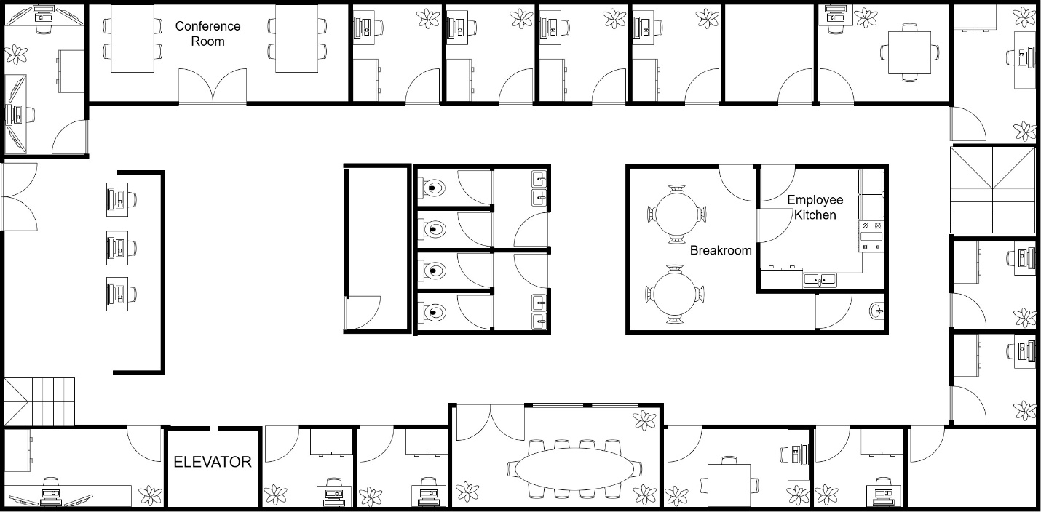
Second Floor
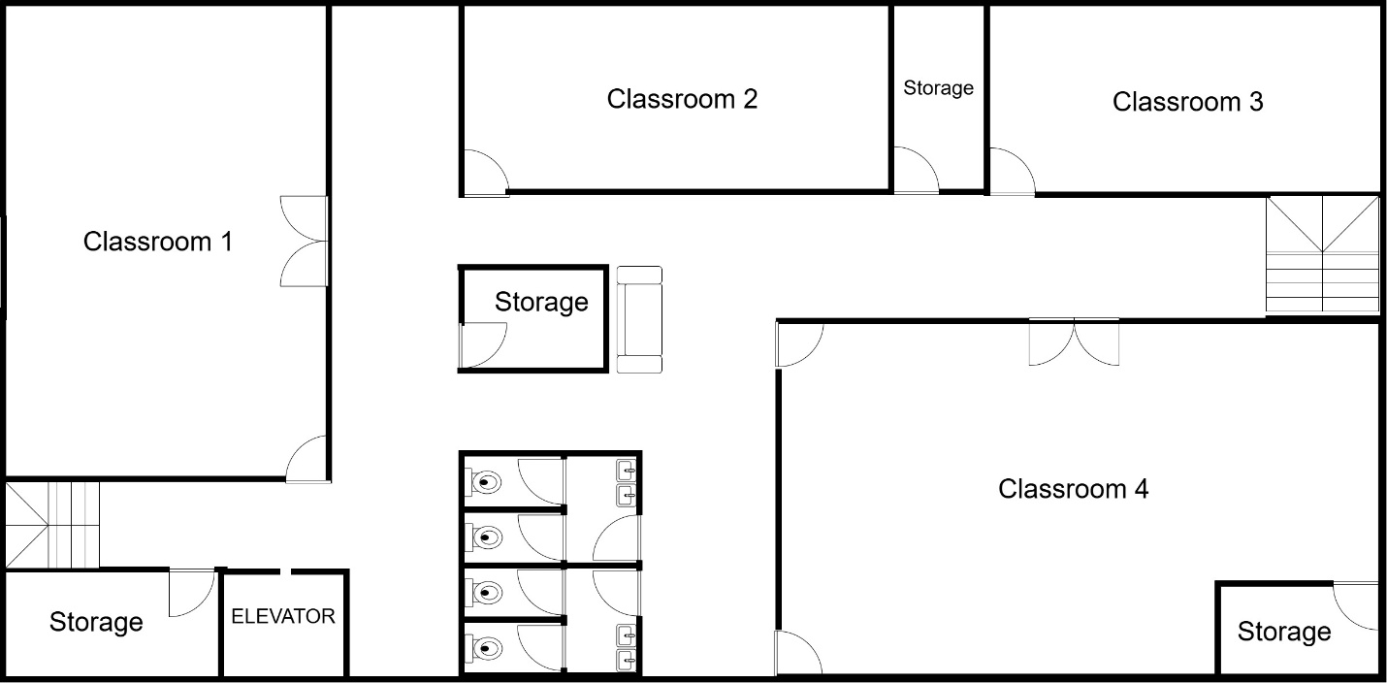

Third Floor
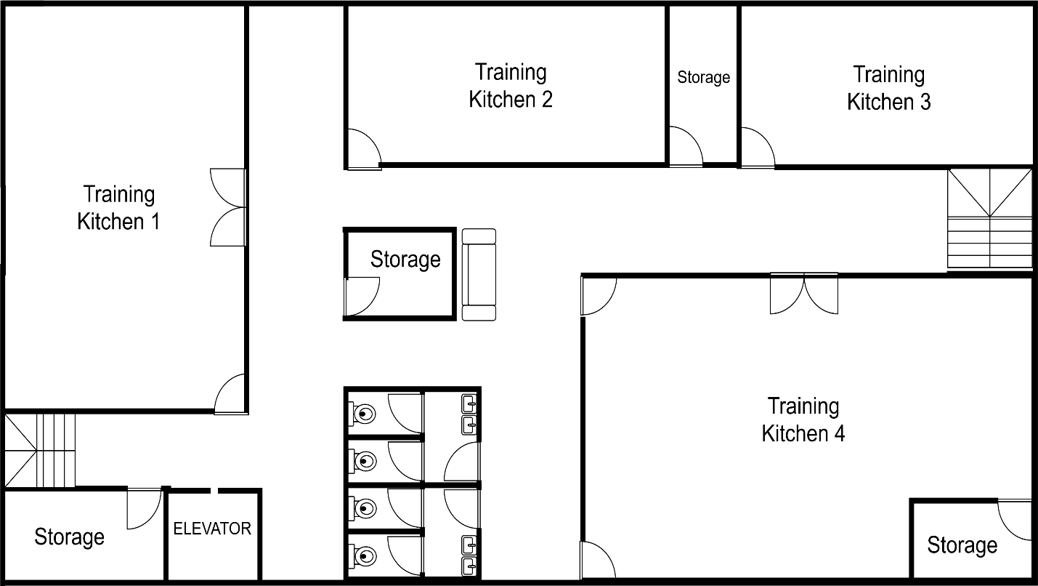
Satellite Locations
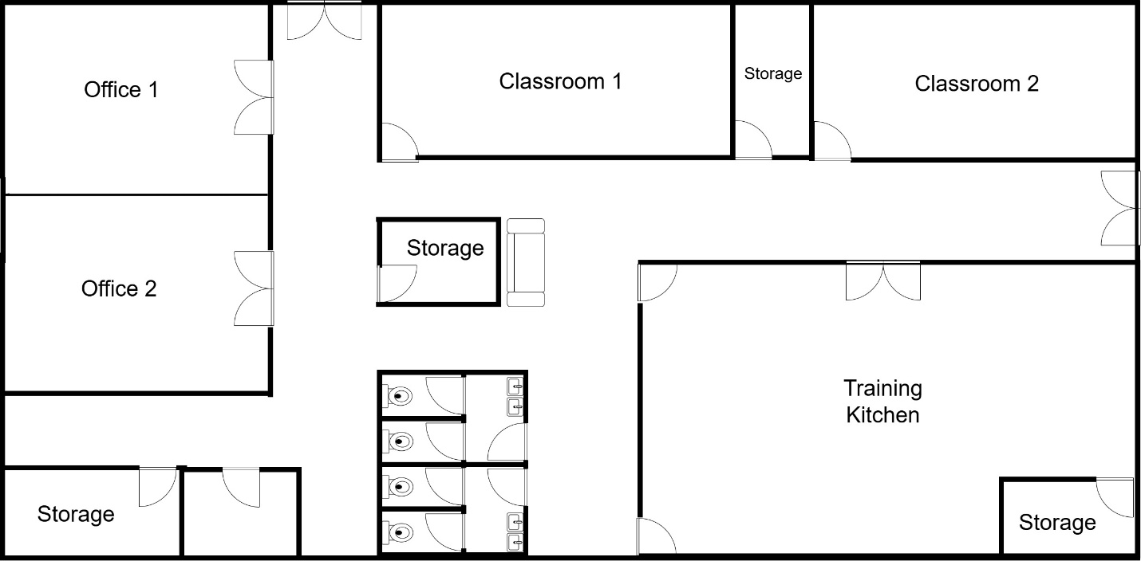

Request For Proposal Response

February 26, 2026
Lou Ann Timmons, CEO
TCTB Technology Solutions
2050 Hwy 501 E; Suite 304C
Conway, SC 29526
Re: Letter of Acceptance – Request for Proposal
Dear Mrs. Timmons,
On behalf of JJAD Development Group, I would like to formally accept the Request for Proposal dated February 11, 2026, regarding the design and development of the new state-of-the-art training facility for TCTB Technology Solutions.
We appreciate the opportunity to collaborate with TCTB Technology Solutions on this important initiative. After reviewing the materials provided, including the outlined hardware, software, and organizational mission and vision, our team is confident in our ability to develop a comprehensive business plan and proposal that aligns with your operational goals and long-term strategic objectives.
JJAD Development Group is committed to delivering a well-researched, innovative, and scalable solution that meets the needs of your instructors, students, and management team. We will ensure that all requirements detailed in the Request for Proposal are carefully addressed during the design and planning phases.
Should any clarifications be required during our review process, we will promptly reach out to you for further discussion. We look forward to submitting our completed proposal and working closely with TCTB Technology Solutions throughout the duration of this project.
Thank you again for the opportunity to serve your organization.
Sincerely,
Julian Vazquez
Julian Vazquez, Project Manager
JJAD Development Group

2050 Hwy 501 E; Bldg. 1000 Suite 322; Conway, SC 29526
Jvazque5@hgtc.edu

Timeline

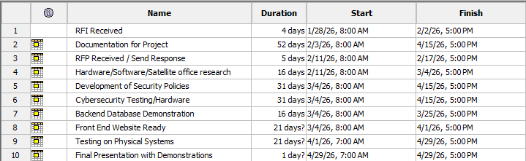
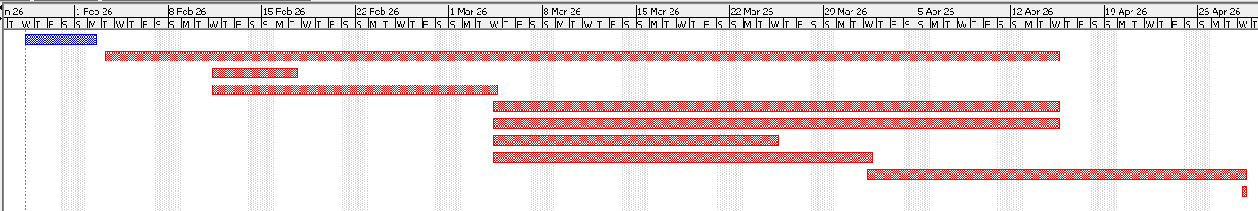
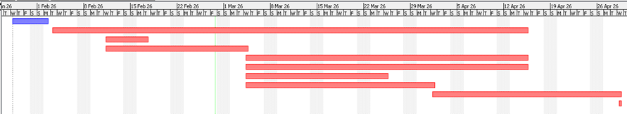

Budget
*Training: Included with installation. Additional training available upon request for $50 per person.
*Shipping: Full costs will be evaluated upon ordering equipment.
*Labor costs contingent upon outsourcing

Floor Plan Information

Legend
Access Point  Monitor
 Camera  POS Keypad
Laptop  POS Printer
 PC Workstation 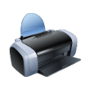 Printer
VOIP Phone 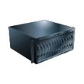 Server
TV  Data Cable
HID Reader  Electronic Lock System

Diagram
First Floor

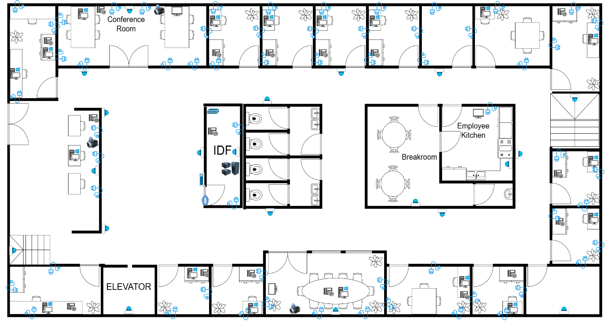

Second Floor

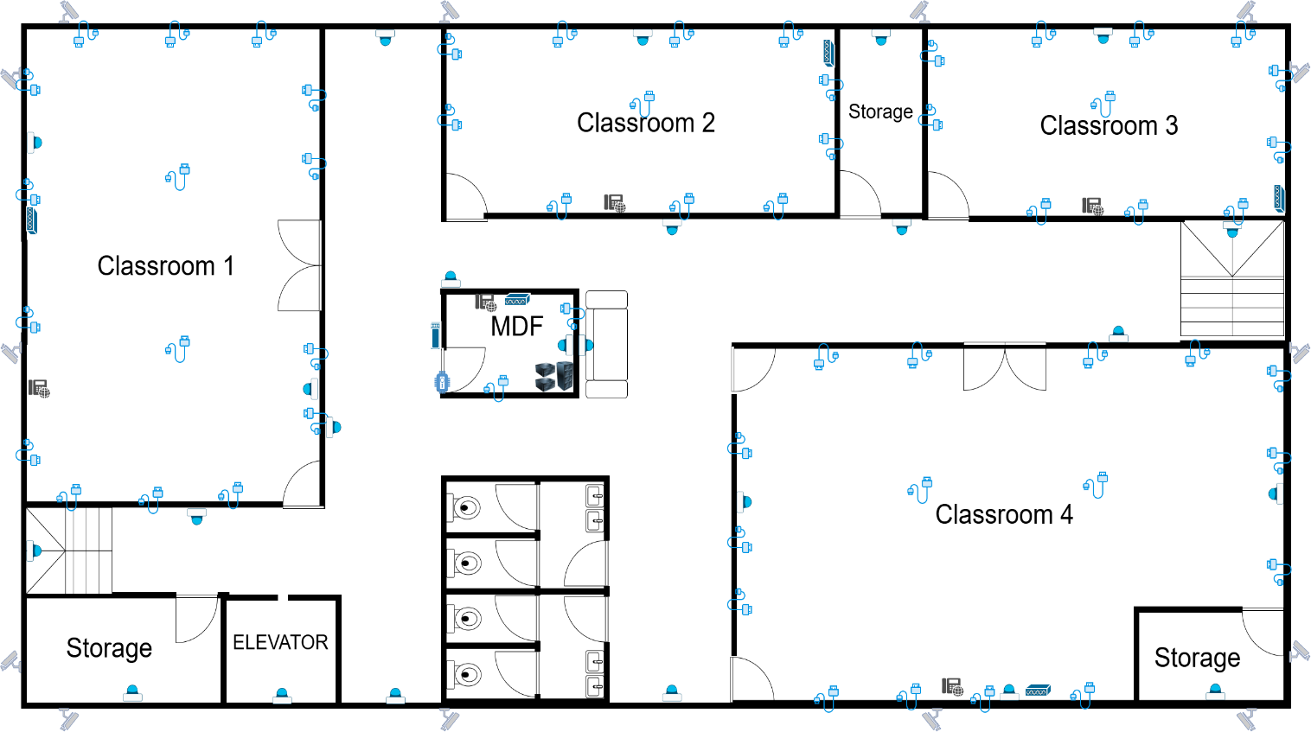

Third Floor

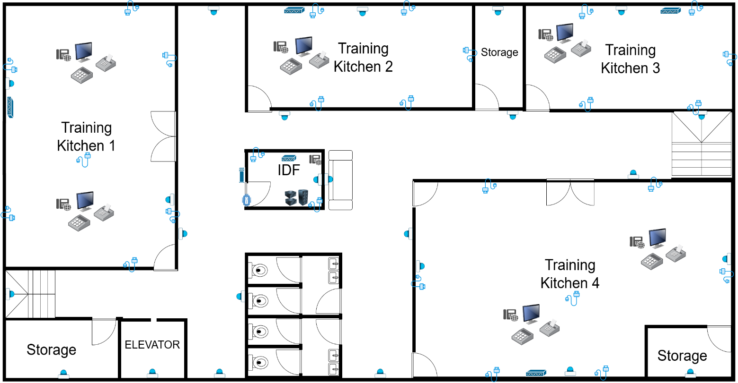

Satellite Buildings

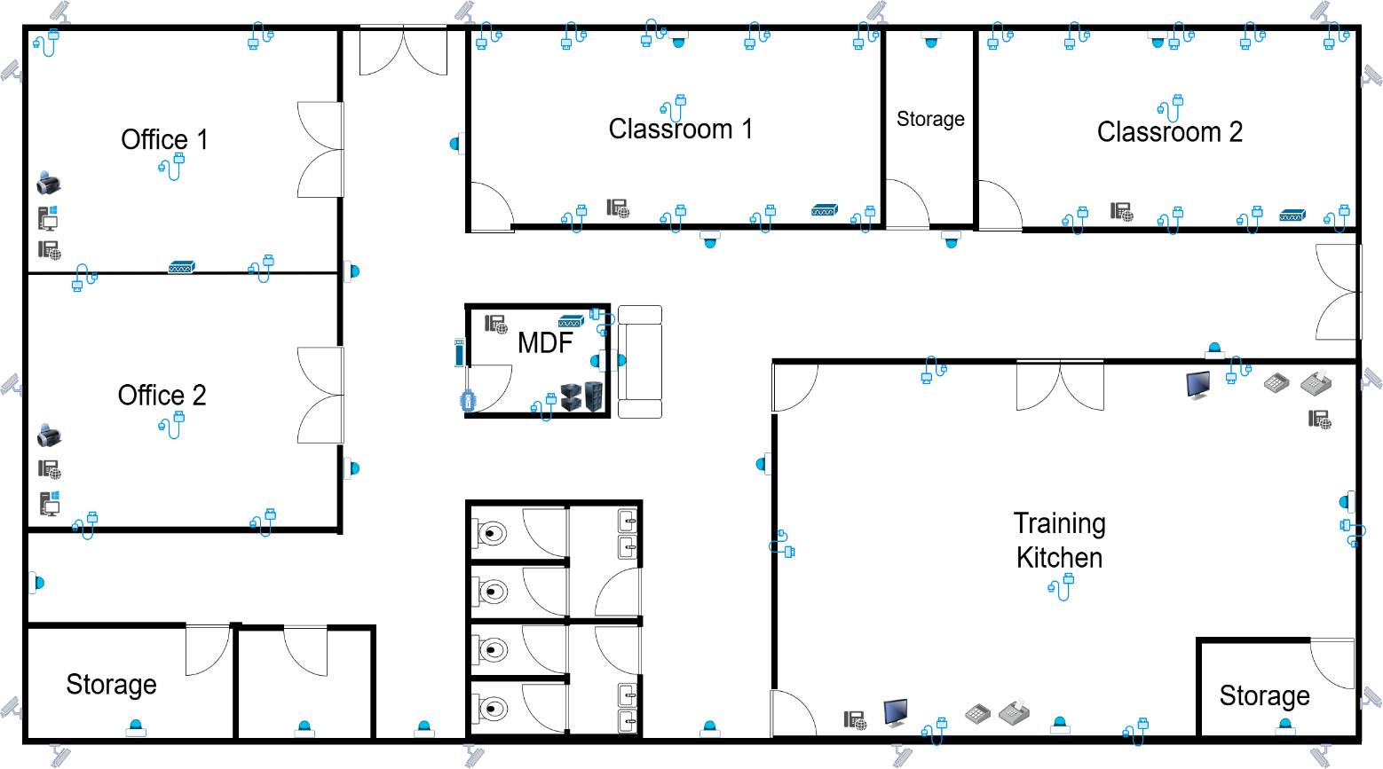

Satellite Locations


Raleigh, NC​
- Tax: 7.25%​
- Outsourcing: No


Orlando, FL​
- Tax: 6.5%​
- Outsourcing: Options available

Hardware
Dell PowerEdge R750
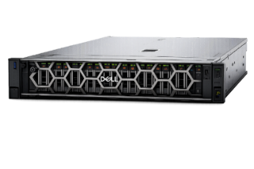
$41,343.33 each
- VMware ESXi Compatible
- Dual Intel Xeon CPUs
- Configured with 4x 64GB RDIMM RAM
- Up to 32 DIMM slots (Supports 2TB+ RAM)
- RAID Storage/Redundant Power Supply
- 4x 480GB SATA SSD
- 2U rack-mount form factor
Add-ons:
- 4x 64GB RDIMM RAM
- 4x 480GB SSD SATA Drives
- Dual, Hot Plug, Power Supply Fault Tolerant 800W
- Additional Power Cord NEMA 5-15P to C13 Wall Plug

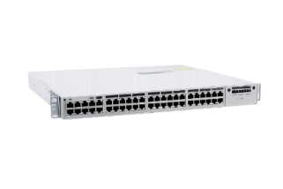
Cisco Catalyst 9300 [Core Switch]
$7,850.00 each
- Cisco IOS-XE with Network advantage license
- QoS support for VoIP/Video traffic
- High throughput switching capacity
- Redundant power supply support
- High-speed 10Gb fiber uplinks

Cisco Catalyst 9200
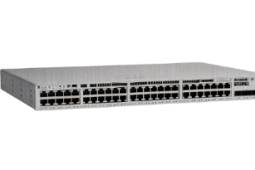
$2,350.00 each
- Cisco IOS XE
- 48-Port Gigabit PoE Access Switch
- VLAN Segmentation support
- QoS for VoIP/Video/POS traffic
- Rack-mount 1U form factor

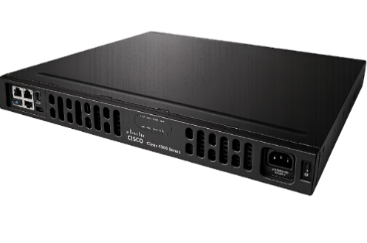
Cisco ISR 4331
$2,159.99 each
- Enterprise WAN Router
- Supports VPN and Secure Site-to Site Connections
- High Performance Routing
- Modular interface slots
- Designed for branch/edge/WAN routing
- Rack-mount capable
- Supports IPSec/SSL VPN

Cisco Firepower 1120
$2,450.00 each
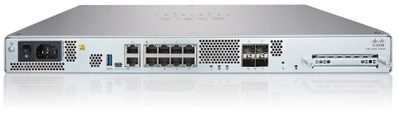
- Protects internal network from internal threats
- IDS/IPS(intrusion detection/prevention)
- Firewall Policies (VLAN Separation enforcement)
- Site-to-site VPN for satellite offices
- Application aware filtering

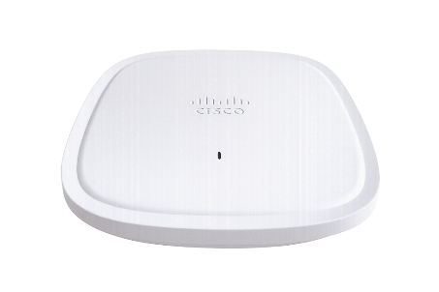
Cisco Catalyst 9130 Wi-Fi 6 Access Point
$825.50 each
- Enterprise-class performance
- Wi-Fi 6 for best throughput
- Secure and manageable via central controller or Catalyst switch
- PoE powered

Dell OptiPlex 7090 Micro / Small Form Factor (SFF)
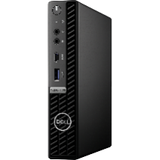
$1,261.44 each
- Intel Core Ultra 5 235 (14 cores up to 5.9GHz)
- 16GB RAM
- 512GB SSD
- Windows 11 Pro
- Enterprise-class reliability
- Easy IT management
- Good performance for general computing and training lab use
- Fits under desks or into small spaces

Dell Latitude 5440 Business Laptop
$1,479.99 each
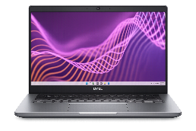
- Intel Core Ultra 5 235U vPro 12 Cores
- 16GB RAM
- 512GB SSD
- Windows 11 Pro
- Corporate-grade build
- Long battery life
- Enterprise security options
- Easy IT deployment

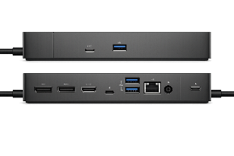
Dell Thunderbolt Dock – WD19TBS
$238.99 each
- Supports up to three 4k Displays
- 1xThunderbolt 3 port, 2x DisplayPort 1.4, 1 HDMI 2.0, 3x USB-A 3.1, 2xUSB-C3.1, and Gigabit Ethernet
- Data rates up to 40Gbps through Thunderbolt 3(High speed USB-C connector)

Dell Wired Mouse MS116
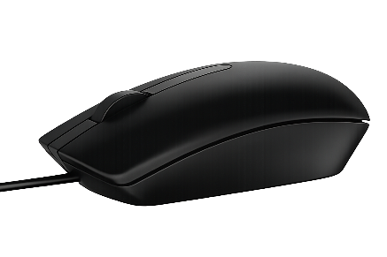
$15.99 each
- Wired USB A Optical mouse
- 1000 DPI
- 2 Buttons + Scroll wheel
- Ambidextrous full-size
- 6ft cable

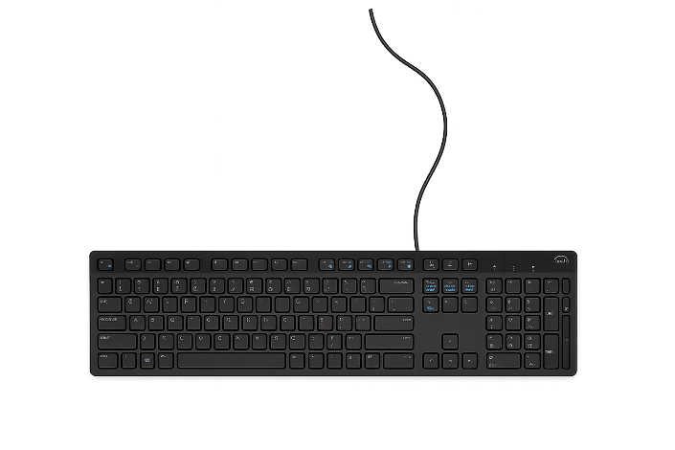
Dell Wired Keyboard KB216
$14.99 each
- USB-A interface
- Width 17.4in
- Weight 17.74 oz
- English layout with Num Pad

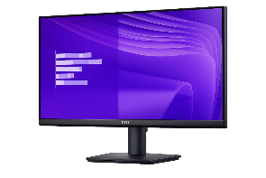
24” Dell SE2425HM Monitor
$99.99 each
- 1920x1080 Full HD
- 100 Hz screen refresh rate
- Wide viewing angles
- Dual Monitor Productivity
- In-plan Switching (IPS) technology

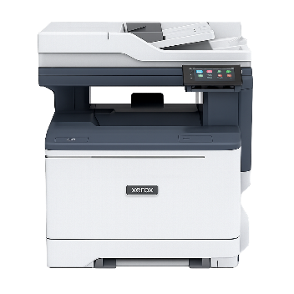
Xerox C Series C325/DNI Wireless All-In-One Color Laser Printer
$499.99 each
- Multifunction printer (Print/Copy/Scan/Fax)
- 1200x1200 dpi, 4800 color quality
- Automatic 2-sided printing
- Up to 35ppm
- 4.3inch touchscreen
- Supports Windows Server 2022

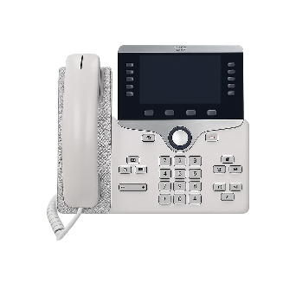
Cisco 8811 IP Phone
$165.55 each
- Enterprise VoIP Standard
- 5inch widescreen color display
- Supports PoE
- High-quality audio
- Works with Cisco Call Manager/CME

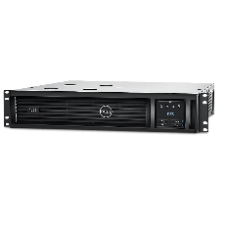
Dell APC Smart-UPS 3000VA Rack-Mountable UPS
$2,810.52 each
- Load Capacity 3000 VA / 2700 W
- LCD Display
- RJ-45 Network port for management
- Supports surge suppression
- Half load runtime 11 minutes/Full load 3 minutes

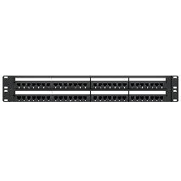
Tripp Lite series N252-048 48-port Cat6 Patch Panel
$182.99 each
- Rated for 1 Gbps speeds
- 48 RJ-45 ports labeled and color coded
- Easy 2U mounting
- Supports Cat5/5e and Cat6

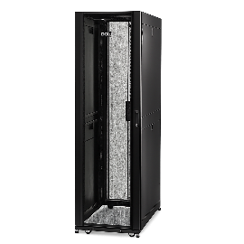
Dell AR3300X717 NetShelter 42U Deep Rack
$3,623.10 each
- Weight limit 2255lbs
- Rack height 42U
- Height: 78inches; Width: 27inches; Depth: 47 inches
- Keyed front and back doors and side panels

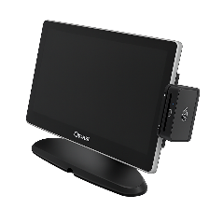
Toast Flex 3 Countertop Terminal
$895.15 each
- 14 inch Full HD display
- Android-based Toast OS
- Integrates with KDS
- Spill-resistant restaurant-grade hardware
- Adjustable stand or wall mount
- Supports guest display + printers +KDS

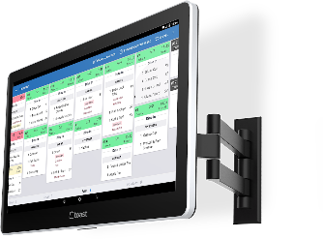
Toast Kitchen Display System (KDS)
$674.15 each
- Counter stand or wall mount
- Full HD touchscreen
- Real-time order display
- Ticket routing by station
- Color-coded order tracking

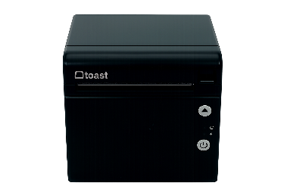
Toast Receipt Printer
$305.20 each
- Thermal receipt printer
- High-volume printing
- Auto cut
- Restaurant grade durability

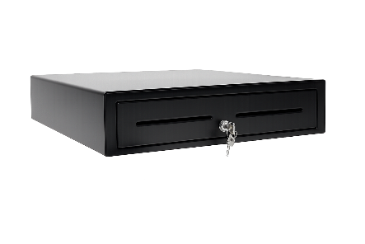
Vasario Series VB320 Cash Drawer
$156.38 each
- Printer-driven POS cash drawer
- 16”x16” standard size
- Steel construction
- 5 bill slots 5 coin slots
- RJ11/RJ12 printer kick cable
- 3 Position lock: Auto, Manual, Locked

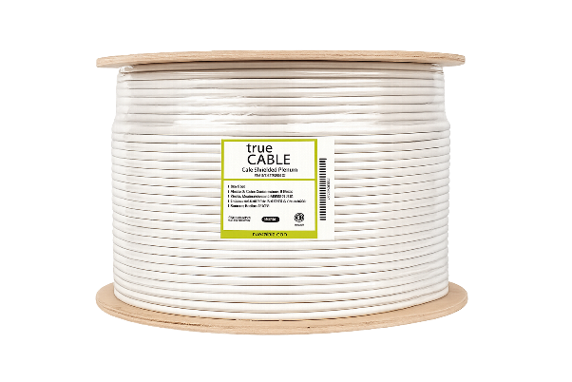
Cat6 Plenum Ethernet Cable | Shielded
$465.99 each
- 1,000 feet
- 23AWG 4-pair, solid bare copper conductors
- Overall aluminum foil shield
- Bandwidth tested up to 550 MHz
- Supports PoE
- cETLus certified, RoHS-3 Compliant

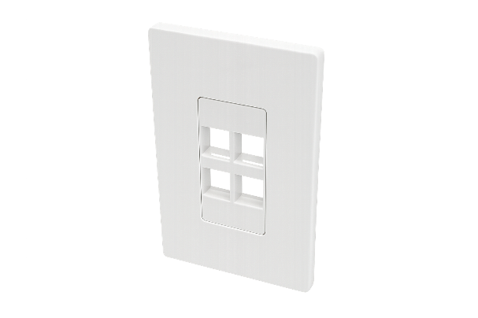
Tripp Lite series 4-Port Keystone Single-Gang Faceplate
$4.99 each
- Compatible with any type of keystone jack
- High-impact polycarbonate construction
- Includes mounting screws

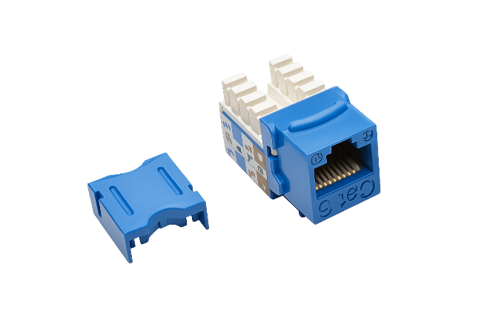
Tripp Lite series Cat6 110 Style Punch Down Keystone Jack
$9.80 each
- Use in Cat6 installations
- Compliant with EIA/TIA Cat6 specifications
- Dual-color coded labeling made for 568A and 568B wiring schemes

Tripp Lite series Cat6 RJ45 Pass-Through UTP Modular Plug, 50 pack
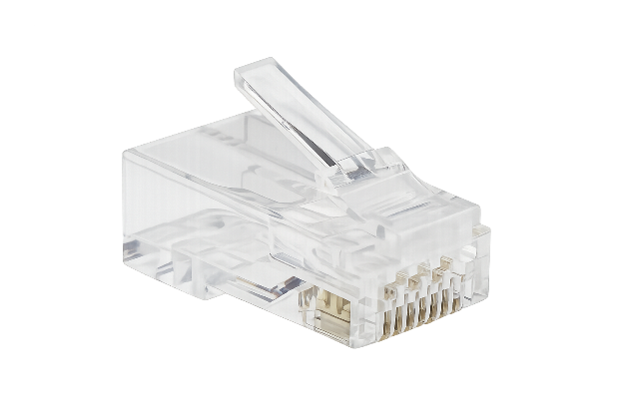
$28.95 each
- Gold plated contacts for premium data transfer
- Works with RJ45 crimping tools and 24-26 AWG UTP Cat6 cables
- Staggered nose pattern reduces near-end crosstalk for clearer transmission

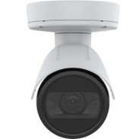
Axis P1448-LE Exterior Camera
$693.99 each
- Outdoor 4K (8 MP) bullet network camera for perimeter/exterior coverage
- Integrated IR illumination (night vision) for low-light areas around the building
- Designed for harsh conditions (weather-resistant housing; vandal-resistant class typically IK10; suitable for exterior mounting)
- PoE powered (single Ethernet drop) to simplify installation and UPS-backed operation
- Wide Dynamic Range / low-light enhancement features (for backlit doors and mixed lighting)
- H.264/H.265 video compression options to reduce bandwidth/storage usage
- Use case in this project: exterior entry points, parking/perimeter, and loading/service areas

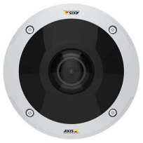
Axis M3058-PLVE Interior 360° Camera
$851.49 each
- 12 MP panoramic fisheye camera providing 360° room coverage from a single mount point
- Ceiling-mount design with dewarped viewing modes (overview + corridor/quad views as needed)
- Integrated IR illumination for low-light indoor areas
- Vandal-resistant housing (typically IK10) suitable for public-facing interior spaces
- PoE powered (single Ethernet drop) for simplified cabling and centralized UPS backup
- H.264/H.265 video compression options to reduce bandwidth/storage usage
- Use case in this project: classrooms, hallways, lobbies, and open areas where wide coverage is needed

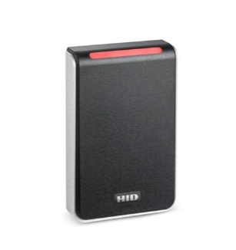
HID Signo Access Control Readers (Signo 20 & Signo 40)
$234.67 each
- Supports HID Mobile Access (Bluetooth/NFC) and common card technologies (iCLASS SE, iCLASS, MIFARE DESFire, MIFARE Classic, and legacy 125 kHz Prox)
- Modern security features for access control deployments (secure element hardware and OSDP Secure Channel support)
- Reader options in this project:
- Signo 20 — mullion-mount reader for narrow door frames
- Signo 40 — wall-switch-mount reader for standard single-gang backboxes
- Use case in this project: controlled entry doors and restricted areas requiring badge and/or mobile credentials
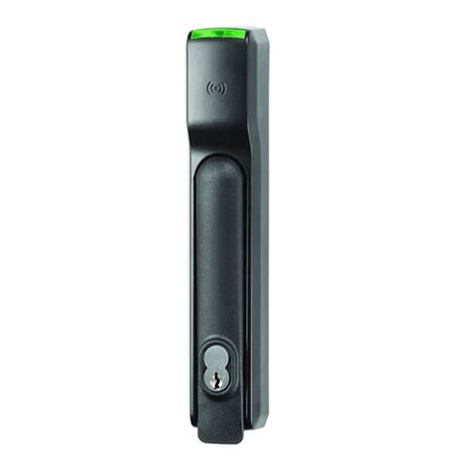
Server Room Electronic Lock System – HES KS200 Series
$1,005.94 each
- Enterprise-grade electronic lock for securing server rooms and IT environments
- Integrates with HID Signo / HID credential ecosystem (Mobile Access, iCLASS SE/Seos, MIFARE DESFire, and legacy Prox)
- Hard-wired Wiegand communication (common with access control panels)
- Fail-secure operation (remains locked on power loss)
- Monitoring features: tamper monitoring and lock-state monitoring
- Mechanical SFIC key override for emergency access
- Power: 12/24 VDC dual-voltage (peak current noted as 130 mA in selected configuration)
- Operating temperature range: 32°F to 122°F

Software
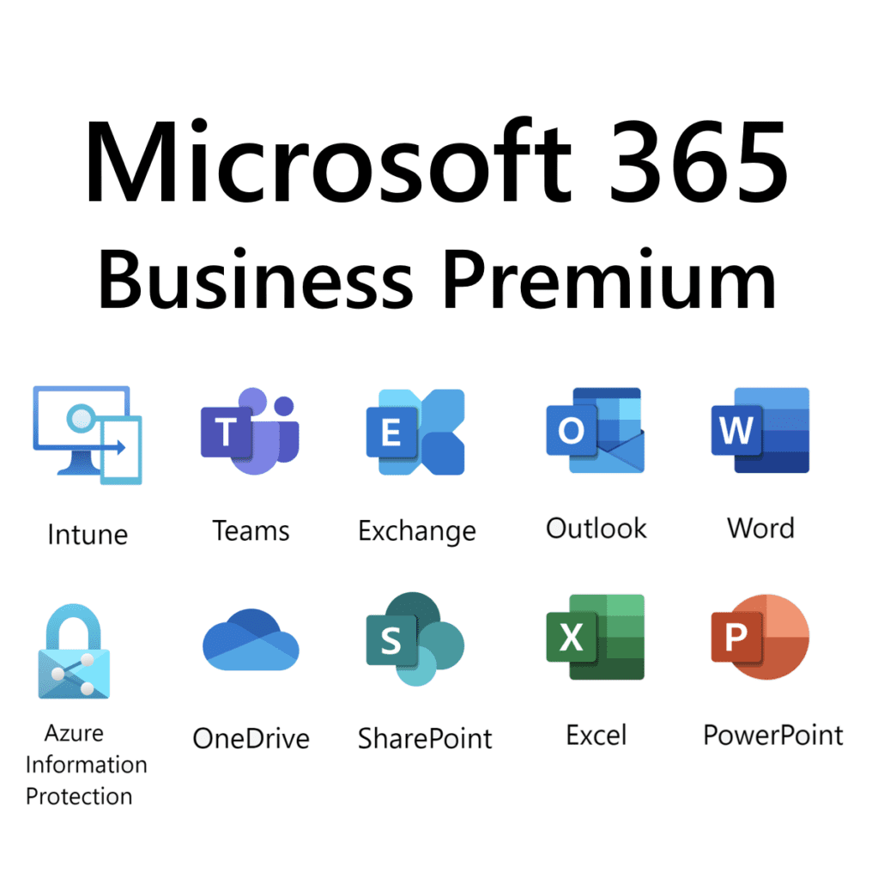

Microsoft 365 Business Premium

Price: $22.00/user/month (annual commitment)
Purpose: Provides business email, Office apps, cloud storage, collaboration tools, device management, and security features.
License: Subscription-based per user/month (annual or monthly billing options available)



Operating Software

Price: $139.00 per device (OEM license typical)

Purpose: Runs instructor workstations, training lab PCs, and administrative systems with enterprise-grade security

License: Per device (OEM or Volume Licensing for organizations)


Cisco Firepower 1120) Network Security

Price: $800 – $1,500 per year per appliance (depending on security bundle and term)

Purpose: Protects network from malware, ransomware, phishing, and unauthorized access; supports VLAN segmentation and content filtering.

License: Subscription-based (1-year, 3-year, or 5-year terms; includes Threat Defense, malware, and URL filtering)


VMware vSphere 8

Price: Starts around $500+ per license/year; enterprise deployments are often significantly higher depending on cores and bundles

Purpose: Virtualization platform for managing servers, applications, and infrastructure.

License: Subscription-based (per core, bundled licensing model required; minimum core requirements apply)


Backup & Disaster Recovery

Price: Quote-based (varies by number of workloads/VMs)

Purpose: Backup and recovery solution for servers, virtual machines, and data protection.

License: Subscription-based (Veeam Universal License – per workload/instance)

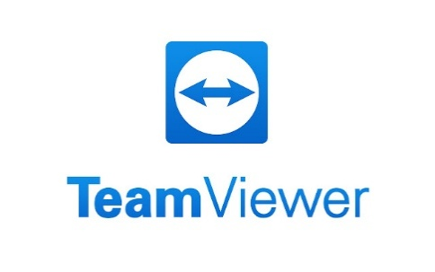

Remote support software

Price: $24.90 monthly per technician (entry-level plans; varies by tier)

Purpose: Allows IT staff to remotely access systems for troubleshooting and support.

License: Subscription-based (per technician/seat)

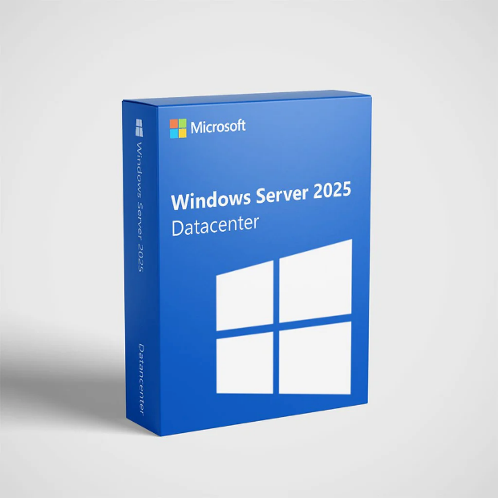

Windows Server 2025 Datacenter
Price: $3,889.99+ (varies based on core count and licensing volume)
Purpose: Provides Active Directory, DNS, DHCP, file services, and centralized authentication.
License: Per core + Client Access Licenses (CALs required for users/devices)


POS Training System

Price: $69/month or quote-based depending on vendor and features
Purpose: Simulates real-world POS operations for training (orders, reporting, table management).
License: SaaS subscription + hardware (bundle pricing varies)


Cisco Catalyst 9300
Price:
3-year term: $1,200 – $2,400
5-year term: $3,100 – $3,900+
7-year term: $3,800 – $5,000+
Purpose: Enterprise network switch running Cisco IOS XE.
License: Cisco Smart Licensing (subscription-based: Network Essentials or Network Advantage tiers)


Cisco Catalyst 9200
Price:
3-year term: $2,000 – $4,000
4-year term: $3,000 – $6,000
Purpose: Enterprise-grade access switch for secure and scalable networking.
License: Cisco DNA subscription licensing (required for feature activation)


Google Chrome Internet Browser
Price: Free (open-source Chromium-based browser)
Purpose: Web browsing, cloud access, and application support.
License: Freeware (enterprise features available via Chrome Enterprise)



Microsoft Edge Internet Browser
Price: Free (including with Windows)
Purpose: Secure web browsing and integration with Microsoft services.
License: Proprietary, included with Windows OS

Recommendations Only

Primary ISP Recommendations
- Compatible with all locations
- Spectrum Business markets dedicated fiber with 24/7/365 support
- Dedicated fiber infrastructure
- High speed performance
- Low Latency (critical for VoIP systems and cloud applications

Secondary ISP Recommendations
- Compatible with all locations
- Strong national fiber backbone
- Advanced infrastructure
- High upload and download speeds
- Enterprise-grade solutions
- Flexible service plans

Security Policies
March 26, 2026


Cyber Analytics, Inc.
2050 E Hwy 501
Suite 323
Conway, SC 20526

RE: Security Policies

To Whom it May Concern:

On behalf of JJAD Development Group, I would like to thank your company for reviewing our hardware recommendations for the TCTB Technology Solutions project. Our goal is to provide the most secure hardware and highest security for the state-of-the-art training facility.

With that goal in mind, we respectfully request your expertise and professional services to review the following security policies recommended to TCTB Technology Solutions:

- Backup and Disaster Recovery Policy
- Password policy

We would appreciate a review for accuracy and completeness to ensure that no critical security measures have been overlooked. A response by April 5, 2026 would be greatly appreciated to allow sufficient time for presentation of the policies to TCTB for approval.

If you have any questions or require additional information, please feel free to contact me. Thank you in advance for your time and expertise.

Sincerely,

Julian Vazquez
Project Manager
JJAD Development Group

2050 Hwy 501 E; Bldg. 1000 Suite 322; Conway, SC 29526
Jvazque5@hgtc.edu

Password Policy Recommendation
Below are recommendations for TCTB Technology Solutions to implement on their network to ensure security is maintained.
Distribute and train users on the below information regularly and have users sign and date for training and understanding.
- Passwords must be a minimum of 10 characters.
  - Recommend at least 14 characters in length to be more secure and reduce the risk of brute-force attacks
- Passwords must be unique
  - Use a passphrase and/or combinations of uppercase, lowercase, numbers and special characters
- Limit password attempts and implement lock-out policy
  - Enforce password attempts and lock-out policy after a certain number of failed attempts
- Passwords cannot be reused
  - Change passwords every 90 days
- Multi-Factor Authentication will be integrated to add an extra layer of security
  - Use a multi-factor authentication after entering password to ensure is the correct user
- Secure passwords in a safe manner
  - Use of secure password managers is encouraged
  - Never write down and store passwords in or around computers
- Regular training of employees on password security best practices is highly encouraged
- Continuous evaluation and updates to password policies are recommended to ensure the organization is secure from evolving threats and is following best practices
I have read and understand the steps above regarding password policies and protection of the network as outlined by JJAD Development Group Printed Name: _____________________________________________________

Signature: _________________________________________________________

Date: _____________________________________________________________

Backup and Disaster Recovery Policy
Below are the Policies and Procedures to ensure backup and recovery policies are followed to ensure data is properly maintained. The procedures will also indicate the proper steps to recover data in the event of a disaster.
Scope and Applicability:
- Define which systems, users, data types, and devices are recovered by the policy
Backup Frequency and Retention:
- Backup Intervals (example: hourly, daily, weekly)
- When will backup occur? (example: evenings, weekends)
- Retention periods (examples: 90 days, 1 year)
- Versions retained (examples: last 7 versions)
Backup Storage Locations:
- Clarify the following:
  - On-site vs off-site storage
  - Cloud-based or third-party storage
  - Encryption and access controls
Recovery Procedures:
- Define how and when restoration occurs
  - Who will implement the restoration?
  - Will there be practices to ensure speedy recovery
Roles and Responsibilities:
- Assign
  - backup administrators
  - data owners
  - recovery leaders
Above are the recommendations for the Disaster Recovery Policy for TCTB Technology solutions. These items will be discussed and implemented upon acquisition of the project by JJAD Development Group.

Appendix A: Website
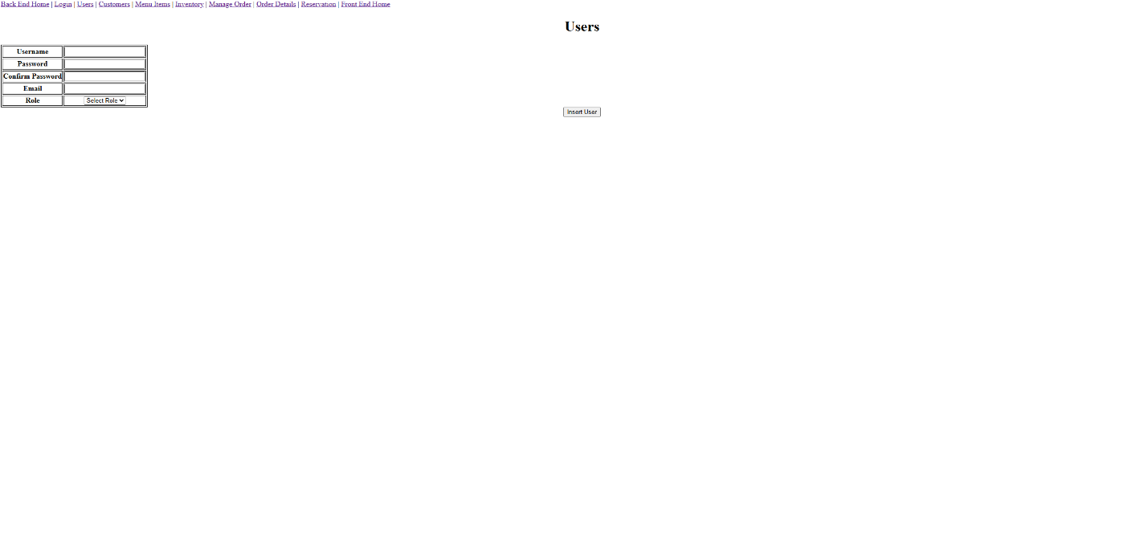

Appendix B: Packet Tracer

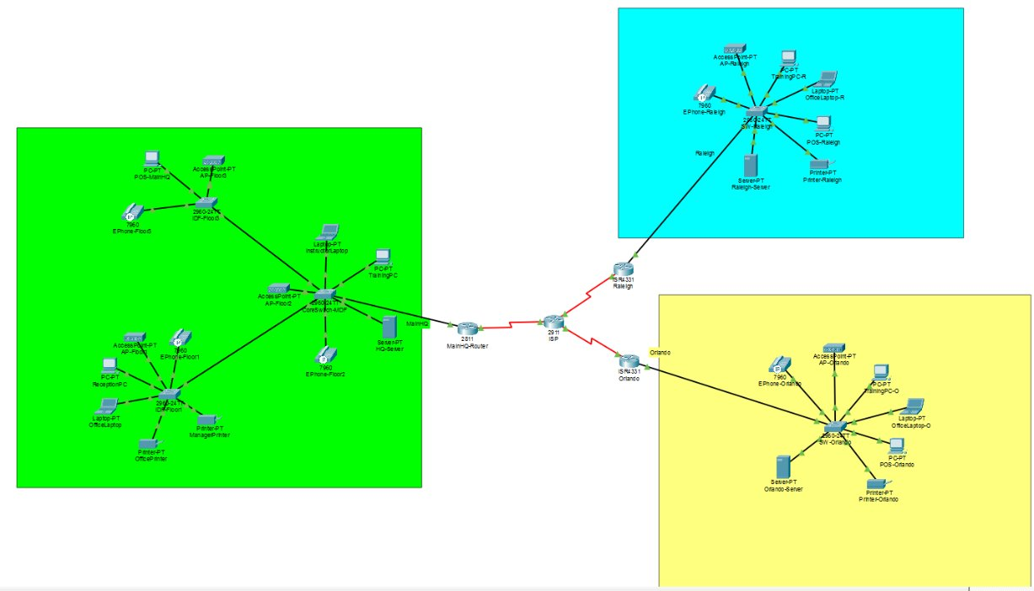
Images from Cisco Networking Academy Packet Tracer. Accessed 10 March 2026

Works Cited
JJAD Logo creation:
OpenAI. Response to “Show me various company logos for JJAD Development Group”. ChatGPT, GPT-5.2, 02-05-2026, chat.openai.com.
Labor Costs:
“Project Manager Salary in Myrtle Beach, SC.” Indeed, Indeed, 30 Jan. 2026, https://www.indeed.com/career/project-manager/salaries/Myrtle-Beach-SC. Accessed 7 Feb. 2026.
“Entry Level Front End Web Developer Salary in Myrtle Beach, SC.” ZipRecruiter. ZipRecruiter, https://www.ziprecruiter.com/Salaries/Entry-Level-Front-End-Web-Developer-Salary-in-Myrtle-Beach-SC. Accessed 7 Feb. 2026.
“Back-End Developer Salary in Myrtle Beach, SC.” Indeed, Indeed, 1 Feb. 2026, https://www.indeed.com/career/back-end-developer/salaries/Myrtle-Beach-SC. Accessed 7 Feb. 2026.
Hardware:
Dell Technologies. PowerEdge R750 Rack Server. Dell Technologies, https://www.dell.com/en-us/shop/serviceselection/pe_r750_14794_vi_vp. Accessed 26 Feb. 2026.
Cisco Systems. Cisco Catalyst 9300 Series Switches. Cisco,
https://www.cisco.com/c/en/us/products/switches/catalyst-9300-series-switches/index.html. Accessed 14 Feb. 2026.
Cisco Systems. Cisco Catalyst 9200 Series Switches. Cisco,
https://www.cisco.com/c/en/us/products/switches/catalyst-9200-series-switches/index.html. Accessed 14 Feb. 2026.
Cisco Systems. Cisco 4331 Integrated Services Router. Cisco,
https://www.cisco.com/c/en/us/support/routers/4331-integrated-services-router-isr/model.html. Accessed 14 Feb. 2026.
Cisco Systems. Cisco Firepower 1000 Series Next-Gen Firewalls. Cisco,
https://www.cisco.com/c/en/us/products/security/firepower-1000-series/index.html. Accessed 16 Feb. 2026.
Cisco Systems. Catalyst 9100 Series Wireless Access Points. Cisco,
https://www.cisco.com/c/en/us/products/wireless/campus-wireless-access-points/index.html. Accessed 16 Feb. 2026.
Cisco Systems. Cisco Firepower 1000 Series Next-Generation Firewalls. Cisco,
https://www.cisco.com/c/en/us/products/security/firepower-1000-series/index.html. Accessed 20 Feb. 2026.
Cisco Systems. Cisco Catalyst 9130AX Series Access Points. Cisco,
https://www.cisco.com/c/en/us/products/wireless/catalyst-9130ax-series-access-points/index.html. Accessed 20 Feb. 2026.
Dell Technologies. Dell OptiPlex 7090 Micro Desktop. Dell,
https://www.dell.com/en-us/shop/desktops-all-in-one-pcs/optiplex-7090-micro-desktop/spd/optiplex-7090-micro. Accessed 20 Feb. 2026.
Dell Technologies. Dell Latitude 5440 Laptop. Dell,
https://www.dell.com/en-us/shop/laptops/latitude-5440-laptop/spd/latitude-14-5440-laptop. Accessed 20 Feb. 2026.
Dell Technologies. Dell Thunderbolt Dock – WD19TBS. Dell,
https://www.dell.com/en-us/shop/dell-thunderbolt-dock-wd19tbs/apd/210-azbi/pc-accessories. Accessed 20 Feb. 2026.
Dell Technologies. Dell 24 Monitor – SE2425HM. Dell,
https://www.dell.com/en-us/shop/dell-24-monitor-se2425hm/apd/210-bqjz/monitors-monitor-accessories. Accessed 20 Feb. 2026.
Dell Technologies. Xerox C Series C325/DNI Wireless Color All-In-One Laser Printer with Fax. Dell, https://www.dell.com/en-us/shop/xerox-c-series-c325-dni-wireless-color-all-in-one-laser-printer-with-fax/apd/ad085180/printers-ink-toner. Accessed 28 Feb. 2026.
Cisco Systems, Inc. Cisco IP Phone 8841. Cisco, https://www.cisco.com/c/en/us/products/collaboration-endpoints/ip-phone-8841/index.html. Accessed 28 Feb. 2026.
Dell Technologies. Dell-APC Smart-UPS 3000VA Rack-mountable UPS. Dell, https://www.dell.com/en-us/shop/dell-apc-smart-ups-3000va-rack-mountable-ups/apd/aa839561/power-cooling-data-center-infrastructure. Accessed 28 Feb. 2026.
Eaton Corporation. Tripp Lite Series 48-Port Cat6 Patch Panel – UTP, 110 Punch Down, RJ45, 2U, TAA (N252-048). Eaton, https://tripplite.eaton.com/48-port-2u-rack-mount-cat6-cat5-110-patch-panel-568b-rj45-ethernet~N252048. Accessed 28 Feb. 2026.
Dell Technologies. Dell AR3300X717 NetShelter SX 42U Deep Rack – 600mm Wide x 1200mm – Black with Sides & Doors. Dell, https://www.dell.com/en-us/shop/dell-ar3300x717-netshelter-sx-42u-deep-rack-600mm-wide-x-1200mm-black-w-sides-doors/apd/ab118548/power-cooling-data-center-infrastructure. Accessed 1 Mar. 2026.
Toast, Inc.
“Toast POS Hardware.”
Toast, https://pos.toasttab.com/hardware.
Accessed 2 Mar. 2026.
Toast, Inc.
“Kitchen Display System (KDS).”
Toast, https://pos.toasttab.com/products/kitchen-display-system.
Accessed 2 Mar. 2026.
KORONA POS.
“Toast POS Cost Calculator & Pricing Guide.”
KORONA POS, https://koronapos.com/blog/toast-pos-cost-calculator/.
Accessed 2 Mar. 2026.
APG Cash Drawer, LLC. Standard-Duty Point of Sale Cash Drawer | Vasario Series VB320-1-BL1616. APG Solutions, https://apgsolutions.com/cash-drawer/genesis-cash-drawer-vb320-1-bl1616/. Accessed 2 Mar. 2026.
Dell Technologies. Dell Wired Mouse – MS116 – Black. Dell, https://www.dell.com/en-us/shop/dell-wired-mouse-ms116-black/apd/275-bbcb/pc-accessories. Accessed 2 Mar. 2026.
Dell Technologies. “Dell Wired Keyboard – KB216 – US English – Black.” Dell,
https://www.dell.com/en-us/shop/dell-wired-keyboard-kb216-us-english-black/apd/580-admt/pc-accessories.
Accessed 7 Mar. 2026.
True Cable. “Cat6 Plenum Ethernet Cable | Shielded.” TrueCable,
https://www.truecable.com/collections/cat6-cable/products/cat6-plenum-ethernet-cable-shielded-1000ft.
Accessed 7 Mar. 2026.
Eaton. “Tripp Lite Series 4-Port Keystone Single-Gang Faceplate, White, TAA.” Eaton,
https://tripplite.eaton.com/4-port-single-gang-universal-keystone-wallplate-white~N080104.
Accessed 8 Mar. 2026.
Eaton. “Tripp Lite Series Cat6/Cat5e 110 Style Punch Down Keystone Jack – Blue, TAA.” Eaton,
https://tripplite.eaton.com/cat6-cat5e-110-style-punch-down-keystone-jack-blue~N238001BL.
Accessed 8 Mar. 2026.
Eaton. “Tripp Lite Series Cat6 RJ45 Pass-Through UTP Modular Plug, 50 Pack, TAA.” Eaton,
https://tripplite.eaton.com/rj45-pass-through-utp-modular-plugs-cat6-50-pack~N232050UTP.
Accessed 8 Mar. 2026.
Software:
“Microsoft 365 Business Premium.” Microsoft 365, Microsoft, n.d., https://www.microsoft.com/en-us/microsoft-365/business/microsoft-365-business-premium. Accessed 22 Feb. 2026.
“Understanding the TeamViewer pricing: How much it cost?” RealVNC Blog, RealVNC, 23 Apr. 2024, https://www.realvnc.com/en/blog/teamviewer-pricing/. Accessed 22 Feb. 2026.
“Veeam Platform Pricing and Packaging.” VMBackupWorks.com, VMBackupWorks, n.d., https://www.vmbackupworks.com/Veeam-pricing.asp. Accessed 22 Feb. 2026.
“Cisco FirePOWER Threat Defense, Malware and URL—Subscription License (1 Year)—1 Appliance.” CDW, CDW LLC, n.d., https://www.cdw.com/product/cisco-firepower-threat-defense-malware-and-url-subscription-license-1-y/5674007. Accessed 22 Feb. 2026.
“Buy and Download Windows 11 Home.” Microsoft Store, Microsoft, n.d., https://www.microsoft.com/en-us/d/windows-11-home/dg7gmgf0krt0. Accessed 23 Feb. 2026.
“Flexible pricing options for every restaurant and retailer.” Toast POS, Toast, Inc., n.d., https://pos.toasttab.com/pricing. Accessed 23 Feb. 2026.
Microsoft. Professional Business Email Address | Microsoft 365. Microsoft, https://www.microsoft.com/en-us/microsoft-365/business/business-email-address. Accessed 2 Mar. 2026.
“VMware vCenter Server 8 Standard + vSphere 8 Enterprise Plus BUNDLE – Lifetime Licenses.” ProductKeys.com, https://www.productkeys.com/product/vmware-vcenter-server-8-standard-vsphere-8-enterprise-plus-bundle-cd-key/?utm_source=Google%20Shopping&utm_campaign=BuyKeys-GoogleFeed&utm_medium=cpc&utm_term=493690&gad_source=1&gad_campaignid=19420908395&gbraid=0AAAAACuOYnitbwYKl8G5SJle-4yjHmgPC&gclid=CjwKCAiAh5XNBhAAEiwA_Bu8FQ006MZrba3dN25XMiTgPKAdCQa6p73BJWpWBVvtLEz2Bm1ZOZrQqxoCcowQAvD_BwE. Accessed 2 Mar. 2026.
“Microsoft Windows Server 2025 Datacenter 16-Core License.” TrustedTechTeam.com, https://www.trustedtechteam.com/products/microsoft-windows-server-2025-datacenter-16-core-license?utm_source=google&utm_medium=cpc&utm_campaign=Gshop_WSMedNC}&utm_term=&cq_plac=&cq_net=g&cq_pos=&cq_med=pla&cq_plt=gp&gc_id=15699361846&h_ad_id=571875952559&gad_source=1&gad_campaignid=15699361846&gbraid=0AAAAADN2SjfwUDsVw1EfAv0G1lcrTnGzp&gclid=CjwKCAiAh5XNBhAAEiwA_Bu8FdF8TnZ6tj-bCRgAClSLLHvI08ToSHMoLSZ1uDPX1O0l9R6_yELwyBoCraEQAvD_BwE. Accessed 2 Mar. 2026
Lodhi, Taha. “Cisco License Cost and Renewal Considerations in 2026.” ORMSYSTEMS, 16 Oct. 2025, https://ormsystems.com/blogs/cisco-license-cost-and-renewal-considerations-in-2026?utm_. Accessed 2 Mar. 2026
C9300-DNA-A-24S-7Y Price | Cisco Catalyst 9300 Series License. ORMSystems, https://ormsystems.com/c9300-dna-a-24s-7y-price.html?utm_. Accessed 2 Mar. 2026.
“Restaurant Software Pricing.” Restaurant365, Restaurant365, n.d., https://www.restaurant365.com/pricing/. Accessed 23 Feb. 2026.
Axis Communications. AXIS P1448-LE Network Camera—Product Support. Axis Communications,
https://www.axis.com/products/axis-p1448-le/support. Accessed 2 Mar. 2026.
Axis Communications. AXIS M3058-PLVE Network Camera—Product Support. Axis Communications,
https://www.axis.com/products/axis-m3058-plve/support. Accessed 2 Mar. 2026.
HID Global. HID Signo Readers—Datasheet. HID Global,
https://www.hidglobal.com/products/readers-and-credentials/readers/signo. Accessed 2 Mar. 2026.
HID Global. HID Signo Readers Family—Datasheet. HID Global,
https://www.hidglobal.com/documents/signo-readers-ds-en. Accessed 2 Mar. 2026.
HID Global. HID Signo Reader 20—Product Page. HID Global,
https://www.hidglobal.com/products/signo-reader-20. Accessed 2 Mar. 2026.
HID Global. HID Signo Reader 40—Product Page. HID Global,
https://www.hidglobal.com/products/signo-reader-40. Accessed 2 Mar. 2026.
ASSA ABLOY Opening Solutions. HES KS200 Series Cabinet Lock—Product Information. ASSA ABLOY,
https://www.assaabloy.com/us/en/solutions/products/electromechanical-locks/hes-ks200. Accessed 2 Mar. 2026.
ASSA ABLOY Opening Solutions. HES KS200 Series Cabinet Lock—Overview. ASSA ABLOY,
https://www.assaabloy.com/us/en/solutions/products/electromechanical-locks/hes-ks200. Accessed 2 Mar. 2026.
ASSA ABLOY Opening Solutions. HES KS200 Series Cabinet Lock—Specifications. ASSA ABLOY,
https://www.assaabloy.com/us/en/solutions/products/electromechanical-locks/hes-ks200. Accessed 2 Mar. 2026.
HES. KS210-S Cabinet Lock—Product Listing. HES,
https://www.hesinnovations.com/en/products/cabinet-locks/ks-series. Accessed 2 Mar. 2026.
“Visual Code Studio. Jarrod Brown and Dmitry Sitnikov with Training Center Website”, generated through Visual Code Studio, 23 Mar. 2026.

Leave blank

Back cover page

