Jarrod Brown
Milestone 3

Execution Order
Step | Table | Why This Order Works
1 | category, customer, employee, supplier | These tables do not depend on other tables.
2 | customerprofile, inventoryitem | These rely on Customer, Category, and Supplier existing first.
3 | customerorder | Each order requires a valid customer and employee.
4 | orderitem, payment | Each row requires an existing order; orderitem also requires an item.
5 | tradetransaction | Each trade requires an existing customer and employee.

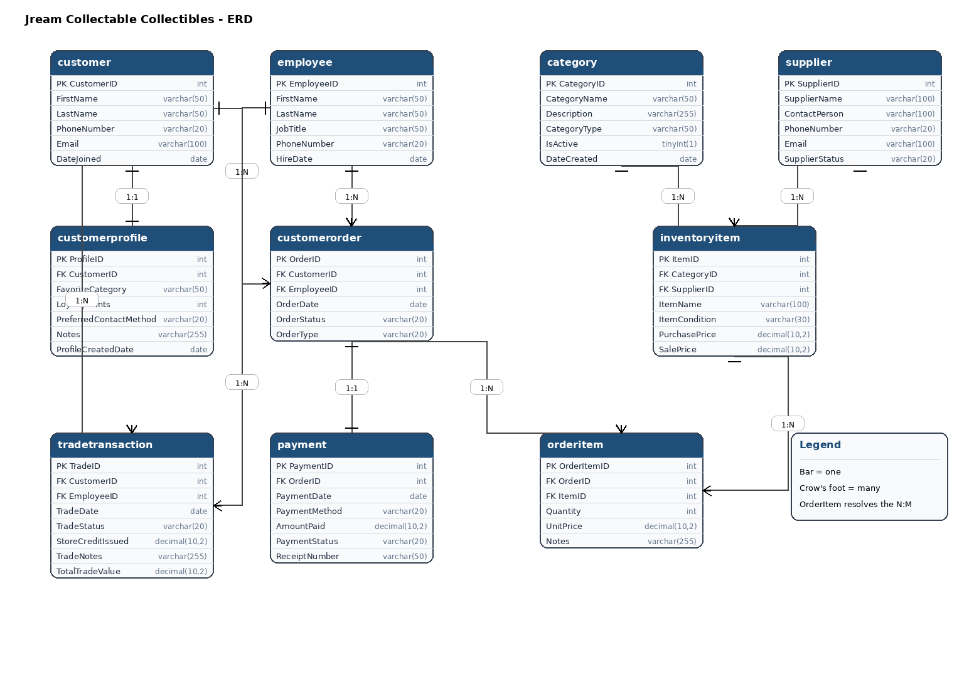

START TRANSACTION;

INSERT INTO category (CategoryID, CategoryName, Description, CategoryType, IsActive, DateCreated) VALUES
(1, 'Sports Cards', 'Trading cards from major sports leagues', 'Cards', 1, '2026-04-01'),
(2, 'Pokemon', 'Pokemon cards and sealed products', 'TCG', 1, '2026-04-01'),
(3, 'Comics', 'Comic books and graphic novels', 'Books', 1, '2026-04-01'),
(4, 'Figures', 'Action figures and collectible statues', 'Merchandise', 1, '2026-04-01'),
(5, 'Memorabilia', 'Signed and display collectible items', 'Collectibles', 1, '2026-04-01'),
(6, 'Gaming', 'Video game related collectibles', 'Media', 1, '2026-04-01');

INSERT INTO customer (CustomerID, FirstName, LastName, PhoneNumber, Email, DateJoined) VALUES
(1, 'Jordan', 'Reed', '843-555-1001', 'jordan.reed@example.com', '2026-04-02'),
(2, 'Mia', 'Carter', '843-555-1002', 'mia.carter@example.com', '2026-04-02'),
(3, 'Noah', 'Bennett', '843-555-1003', 'noah.bennett@example.com', '2026-04-02'),
(4, 'Ava', 'Mitchell', '843-555-1004', 'ava.mitchell@example.com', '2026-04-02'),
(5, 'Ethan', 'Brooks', '843-555-1005', 'ethan.brooks@example.com', '2026-04-02'),
(6, 'Lily', 'Simmons', '843-555-1006', 'lily.simmons@example.com', '2026-04-02');

INSERT INTO employee (EmployeeID, FirstName, LastName, JobTitle, PhoneNumber, HireDate) VALUES
(1, 'Darius', 'King', 'Store Manager', '843-555-2001', '2025-08-15'),
(2, 'Emily', 'Ward', 'Sales Associate', '843-555-2002', '2025-09-01'),
(3, 'Caleb', 'Price', 'Inventory Specialist', '843-555-2003', '2025-09-20'),
(4, 'Nina', 'Lopez', 'Trade Specialist', '843-555-2004', '2025-10-05'),
(5, 'Marcus', 'Hill', 'Cashier', '843-555-2005', '2025-11-10'),
(6, 'Sofia', 'Turner', 'Sales Associate', '843-555-2006', '2026-01-12');

INSERT INTO supplier (SupplierID, SupplierName, ContactPerson, PhoneNumber, Email, SupplierStatus) VALUES
(1, 'Coastal Card Supply', 'Erin James', '843-555-3001', 'contact1@coastalcards.com', 'Active'),
(2, 'Elite TCG Wholesale', 'Brian Foster', '843-555-3002', 'contact2@elitetcg.com', 'Active'),
(3, 'Golden Age Comics', 'Rachel Green', '843-555-3003', 'contact3@goldenagecomics.com', 'Active'),
(4, 'Prime Figure Imports', 'Kevin Stone', '843-555-3004', 'contact4@primefigures.com', 'Active'),
(5, 'Legacy Memorabilia Co', 'Hannah Lee', '843-555-3005', 'contact5@legacymemo.com', 'Active'),
(6, 'Retro Game Distributors', 'Oscar Reed', '843-555-3006', 'contact6@retrogames.com', 'Active');

INSERT INTO customerprofile (ProfileID, CustomerID, FavoriteCategory, LoyaltyPoints, PreferredContactMethod, Notes, ProfileCreatedDate) VALUES
(1, 1, 'Sports Cards', 120, 'Email', 'Frequent buyer of graded cards', '2026-04-02'),
(2, 2, 'Pokemon', 240, 'Text', 'Interested in sealed booster boxes', '2026-04-02'),
(3, 3, 'Comics', 90, 'Email', 'Prefers silver age comic issues', '2026-04-02'),
(4, 4, 'Figures', 160, 'Phone', 'Collects anime figures', '2026-04-02'),
(5, 5, 'Memorabilia', 70, 'Email', 'Looks for autograph authentication', '2026-04-02'),
(6, 6, 'Gaming', 310, 'Text', 'Retro game collector with trade-ins', '2026-04-02');

INSERT INTO inventoryitem (ItemID, CategoryID, SupplierID, ItemName, ItemCondition, PurchasePrice, SalePrice) VALUES
(1, 1, 1, '2025 Topps Chrome Rookie Card', 'Near Mint', 45.00, 79.99),
(2, 2, 2, 'Pokemon Elite Trainer Box', 'Sealed', 32.00, 54.99),
(3, 3, 3, 'Amazing Fantasy Reprint', 'Very Fine', 18.00, 29.99),
(4, 4, 4, 'Limited Edition Anime Figure', 'New', 85.00, 139.99),
(5, 5, 5, 'Signed Team Jersey Display', 'Authenticated', 120.00, 199.99),
(6, 6, 6, 'Retro Game Cartridge', 'Tested', 20.00, 39.99);

INSERT INTO customerorder (OrderID, CustomerID, EmployeeID, OrderDate, OrderStatus, OrderType) VALUES
(1, 1, 2, '2026-04-10', 'Completed', 'In-Store'),
(2, 2, 5, '2026-04-10', 'Completed', 'Online'),
(3, 3, 2, '2026-04-11', 'Completed', 'In-Store'),
(4, 4, 6, '2026-04-11', 'Completed', 'Online'),
(5, 5, 1, '2026-04-12', 'Completed', 'In-Store'),
(6, 6, 5, '2026-04-12', 'Completed', 'Online');

INSERT INTO orderitem (OrderItemID, OrderID, ItemID, Quantity, UnitPrice, Notes) VALUES
(1, 1, 1, 1, 79.99, 'Single graded rookie card'),
(2, 2, 2, 1, 54.99, 'Factory sealed purchase'),
(3, 3, 3, 2, 29.99, 'Customer bought two copies'),
(4, 4, 4, 1, 139.99, 'Collector edition item'),
(5, 5, 5, 1, 199.99, 'Authenticated display piece'),
(6, 6, 6, 3, 39.99, 'Three retro cartridges');

INSERT INTO payment (PaymentID, OrderID, PaymentDate, PaymentMethod, AmountPaid, PaymentStatus, ReceiptNumber) VALUES
(1, 1, '2026-04-10', 'Credit Card', 79.99, 'Paid', 'RCPT-1001'),
(2, 2, '2026-04-10', 'Debit Card', 54.99, 'Paid', 'RCPT-1002'),
(3, 3, '2026-04-11', 'Cash', 59.98, 'Paid', 'RCPT-1003'),
(4, 4, '2026-04-11', 'Credit Card', 139.99, 'Paid', 'RCPT-1004'),
(5, 5, '2026-04-12', 'Credit Card', 199.99, 'Paid', 'RCPT-1005'),
(6, 6, '2026-04-12', 'PayPal', 119.97, 'Paid', 'RCPT-1006');

INSERT INTO tradetransaction (TradeID, CustomerID, EmployeeID, TradeDate, TradeStatus, StoreCreditIssued, TradeNotes, TotalTradeValue) VALUES
(1, 1, 4, '2026-04-13', 'Approved', 35.00, 'Trade-in of duplicate baseball cards', 35.00),
(2, 2, 4, '2026-04-13', 'Approved', 50.00, 'Trade-in of sealed Pokemon tins', 50.00),
(3, 3, 1, '2026-04-14', 'Approved', 22.00, 'Trade-in of comic duplicates', 22.00),
(4, 4, 4, '2026-04-14', 'Approved', 65.00, 'Trade-in of loose figure accessories set', 65.00),
(5, 5, 1, '2026-04-15', 'Approved', 90.00, 'Trade-in of signed baseball with COA', 90.00),
(6, 6, 4, '2026-04-15', 'Approved', 28.00, 'Trade-in of retro gaming magazines', 28.00);
COMMIT;

